**Project 1 - Retail Analysis with Walmart Data**

**Q1 - Which store has maximum sales?**

**Ans 1 :**

Code:

getwd()

setwd('F:/PGP Data Science - Purdue University/PG DS - Data Science with R - Course 3/Project/Assessment Project -1/')

library(csv)

my_walmart = read.csv('Walmart_Store_sales.csv')

### changed date format in data frame since it was in character format before ###

my_walmart$Date = as.Date(my_walmart$Date,format = "%d-%m-%Y")

library(dplyr)

max_sales = aggregate(Weekly_Sales~Store,my_walmart,sum)

class(max_sales)

View(max_sales)

max_sales <- max_sales[order(max_sales$Weekly_Sales,decreasing = T),] ## ordering in decreasing order

View(max_sales)

#Answer is Store number 20, Sales: 301397792

Screenshot:

(i)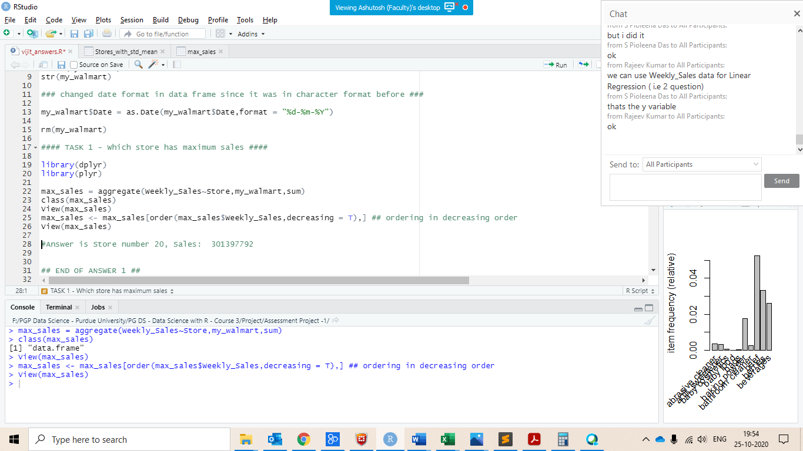 (ii)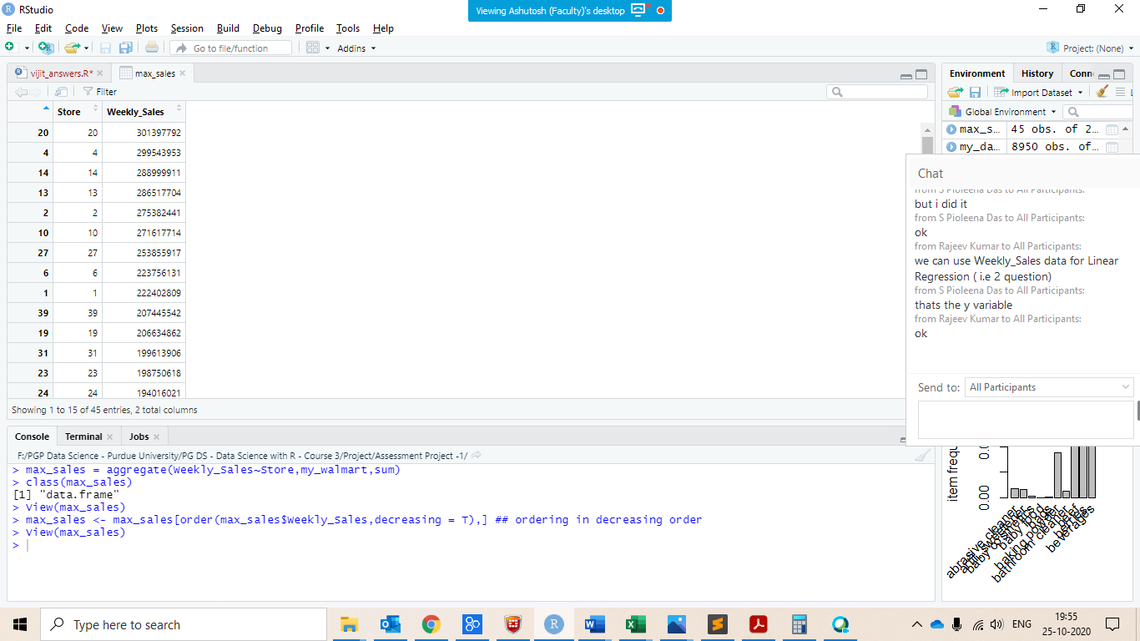

#Answer is Store number 20, Sales: 301397792

**--------------------------------------------------------------------------------------------------------------------------------------------------------------**

**Q2 - Which store has maximum standard deviation i.e., the sales vary a lot. Also, find out the coefficient of mean to standard deviation?**

**Ans 2 –**

Code :

Stores_with_mean = aggregate(Weekly_Sales~Store,my_walmart,mean) #mean

Stores_with_mean

Stores_with_std= aggregate(Weekly_Sales~Store,my_walmart,sd) #standard deviation

Stores_with_std

Stores_with_std <- Stores_with_std[order(Stores_with_std$Weekly_Sales,decreasing = T),]

View(Stores_with_std ) ## ANSWER - STORE 14 has maximum maximum standard deviation 317569.95

Stores_with_std_mean = cbind(Stores_with_mean,Stores_with_std)

str(Stores_with_std_mean)

View(Stores_with_std_mean)

colnames(Stores_with_std_mean)[2] = "Mean_value" # renaming columns

colnames(Stores_with_std_mean)[4] = "Std_value" # renaming columns

View(Stores_with_std_mean)

Stores_with_std_mean = Stores_with_std_mean[,-3]

View(Stores_with_std_mean)

Stores_with_std_mean['Coeff’] = Stores_with_std_mean$Std_value/Stores_with_std_mean$Mean_value ## ANSWER coefficient of mean to standard deviation

View(Stores_with_std_mean)

Screenshot:

1. 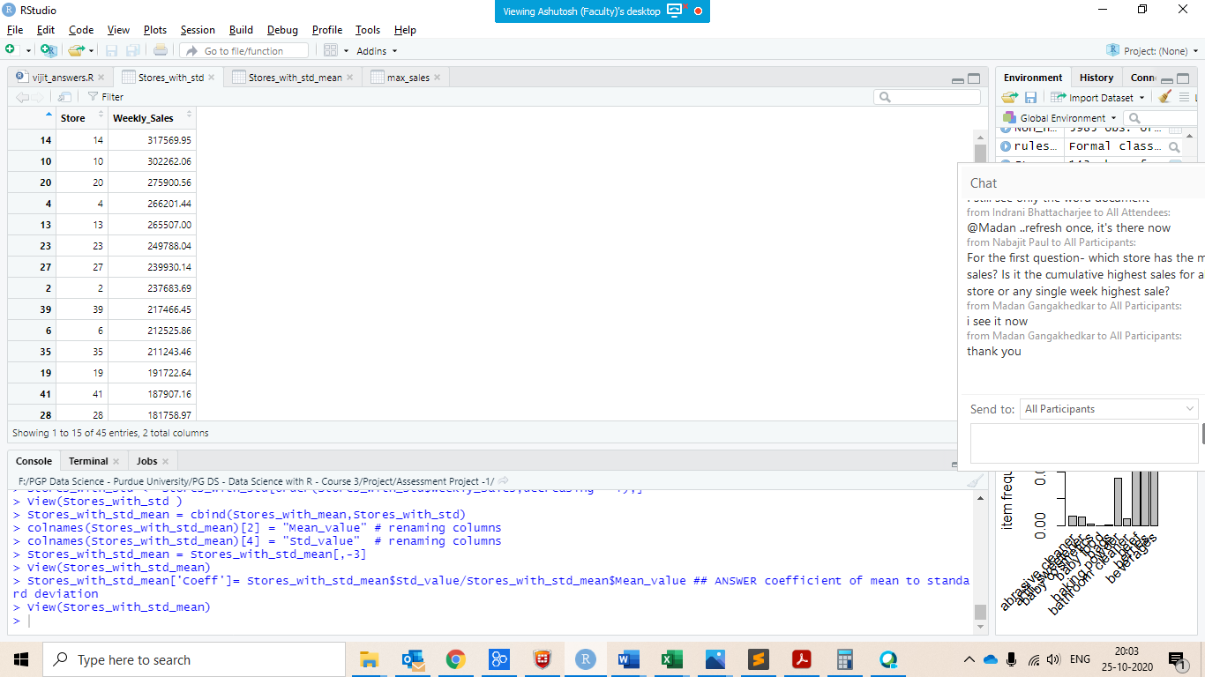 (ii) 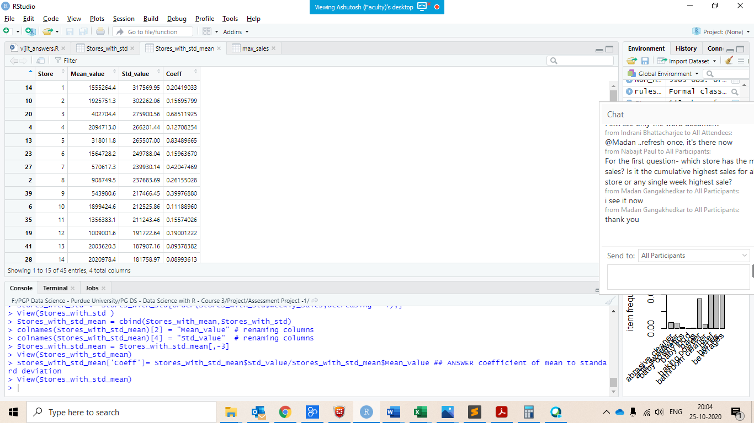

**----------------------------------------------------------------------------------------------------------------------------------------------------------------**

**Q 3 - Which store/s has good quarterly growth rate in Q3’2012?**

**Ans 3 -**

Code :

## taken FINANACIAL YEAR FROM JAN - DEC

Stores_Quarter_Flag = transform(my_walmart,Q_Flag= ifelse((Date>='2012-04-01' & Date<= '2012-06-30'),"Q2_2012",

ifelse((Date>='2012-07-01' & Date<= '2012-09-30'),"Q3_2012","-")))

View(Stores_Quarter_Flag)

# summarizing

Stores_with_Q_Flag_sum = aggregate(Weekly_Sales~Store+Q_Flag,Stores_Quarter_Flag,sum)

View(Stores_with_Q_Flag_sum)

str(Stores_with_Q_Flag_sum)

##then transposing using reshaping

Stores_with_Q_Flag_sum_t = reshape(Stores_with_Q_Flag_sum,idvar="Store",timevar ='Q_Flag',direction="wide")

View(Stores_with_Q_Flag_sum_t)

class(Stores_with_Q_Flag_sum_t)

## calculating growth rate Q3’2012

Stores_with_Q_Flag_sum_t_GR = transform(Stores_with_Q_Flag_sum_t,

GR=((Weekly_Sales.Q3_2012-Weekly_Sales.Q2_2012)/Weekly_Sales.Q2_2012*100))

View(Stores_with_Q_Flag_sum_t_GR)

Stores_with_Q_Flag_sum_t_GR %>% arrange(desc(Stores_with_Q_Flag_sum_t_GR$GR))

## STORE 7 has highest growth rate of 13.33%

Screenshot:

**(i)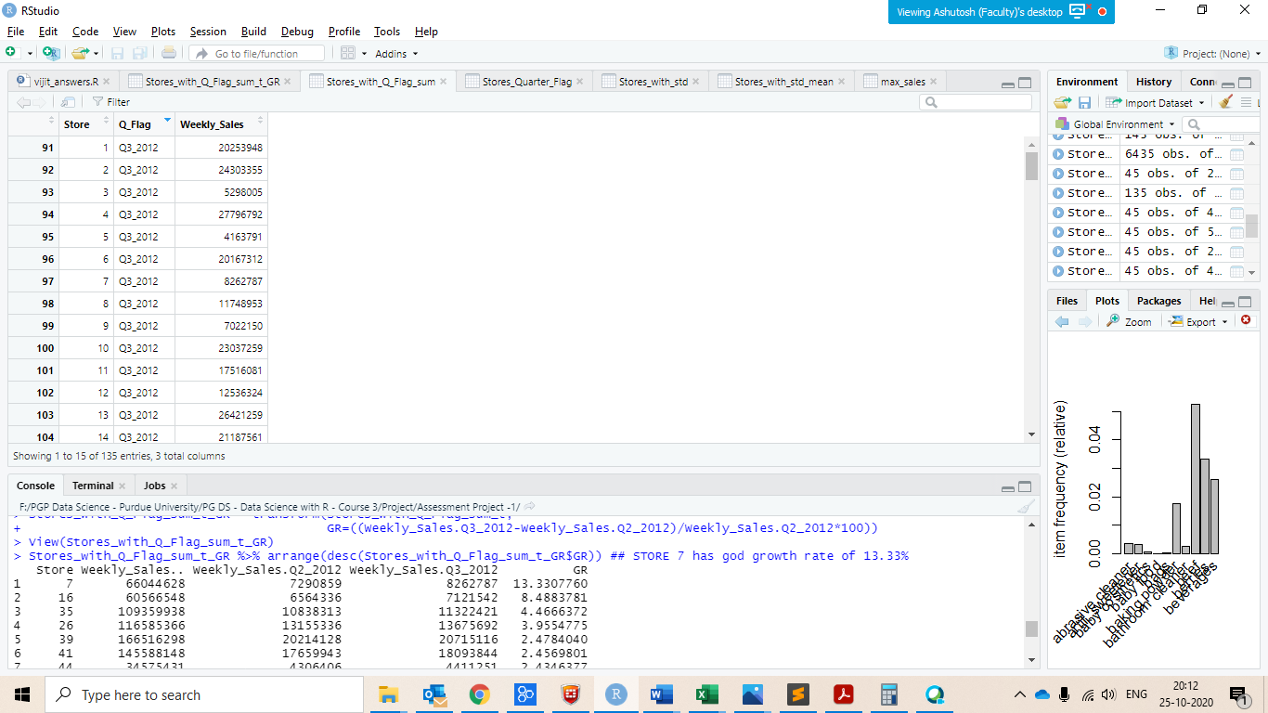 (ii)** 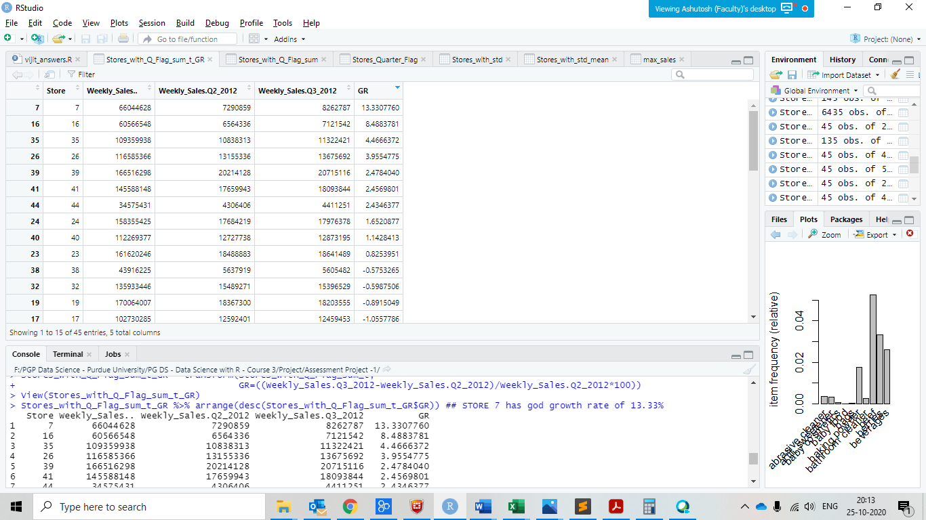

Insights :  
Store 7,16,35,26,39,41,44,24 ,40 , 23 has positive growth rate, Store 7 has highest growth rate of 13.33%

**----------------------------------------------------------------------------------------------------------------------------------------------------**

**Q4 - Some holidays have a negative impact on sales. Find out holidays which have higher sales than the mean sales in non-holiday season for all stores together?**

**Ans 4-**

Code:

View(my_walmart)

Non_Holiday_sales = my_walmart%>%group_by(Weekly_Sales)%>%filter(Holiday_Flag==0)# filtering non holidays weekly_sales

View(Non_Holiday_sales)

avg_non_holiday_sales = mean(Non_Holiday_sales$Weekly_Sales) #mean of weekly sales of non holidays sales

avg_non_holiday_sales

## holiday name added and holidays which have higher sales than the mean sales in non-holiday season

high_sales = filter(my_walmart,Weekly_Sales>avg_non_holiday_sales & Holiday_Flag==1)

high_sales = transform(high_sales,Holiday_name = ifelse((Date=='2010-02-12' | Date== '2011-02-11' | Date== '2012-02-10' | Date=='2013-02-8'),"Super Bowl"

,ifelse((Date=='2010-09-10' | Date== '2011-09-09'| Date== '2012-09-7'| Date=='2013-09-6'),"Labour Day"

,ifelse((Date=='2010-11-26' | Date== '2011-11-25'| Date== '2012-11-23'| Date=='2013-11-29'),"Thanksgiving"

,ifelse((Date=='2010-12-31' | Date== '2011-12-30'| Date== '2012-12-28'| Date=='2013-12-27'),"Christmas","-"

)))))

View(high_sales) ## ANSWER

Screenshot :

(i)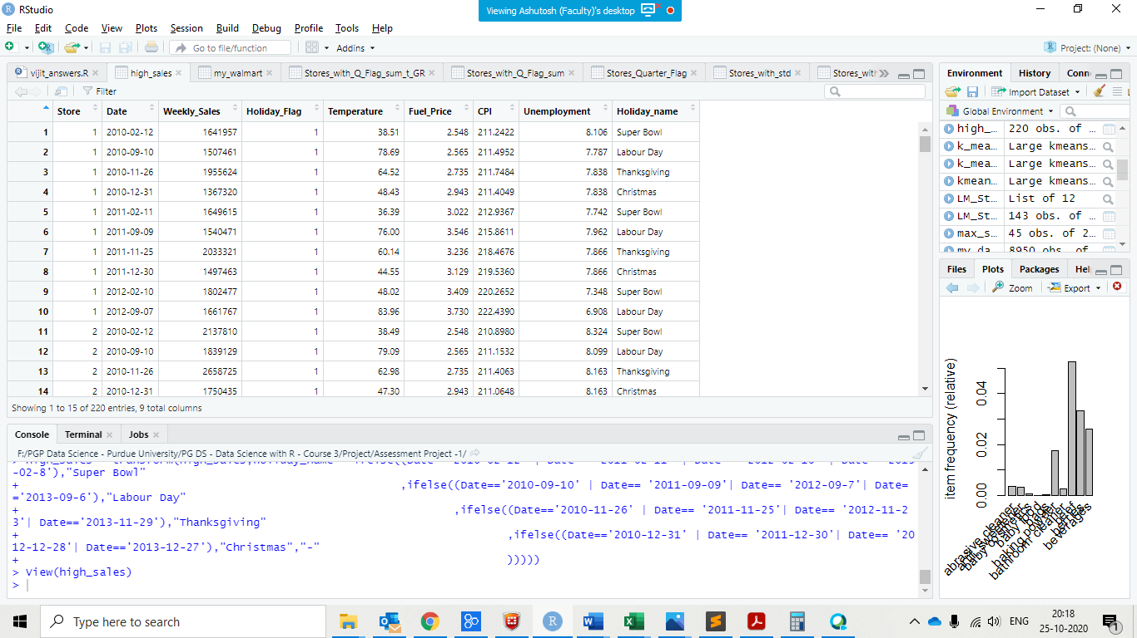

**--------------------------------------------------------------------------------------------------------------------------------------------------------------**

**Q5 - Provide a monthly and semester view of sales in units and give insights?**

**Ans 5 –**

**Code:**

View(my_walmart)

my_walmart$Date = as.Date(my_walmart$Date,format = "%d-%m-%Y")

install.packages('lubridate')

library(lubridate)

my_walmart = transform(my_walmart, Months = months(as.Date(Date,format="%B"))) ## Months column extracted and added

View(my_walmart)

my_walmart = transform(my_walmart, Year = year(as.Date(Date,format="%Y"))) ## Year column extracted and added

View(my_walmart)

#mean of monthly Sales

install.packages('dplyr')

library(dplyr)

library(plyr)

Monthly_Sales = my_walmart%>%group_by(Months)%>%summarise(sum_Monthly_Sales=sum(Weekly_Sales))

View(Monthly_Sales) ## Overall July month has most sales and January has lowest sales

Monthly_mean_Sales = my_walmart%>%group_by(Months)%>%summarise(Mean_Monthly_Sales=mean(Weekly_Sales))

View(Monthly_mean_Sales) ## DEC month as highest average sales, January Month has lowest average sales

Yearly_Sales = my_walmart%>%group_by(Year)%>%summarise(sum_year_Sales=sum(Weekly_Sales))

View(Yearly_Sales) ## Overall year 2011 has highest sales and year 2012 has lowest sales

#Yearly_mean_Sales = my_walmart%>%group_by(Year)%>%summarize(Mean_Year_Sales=mean(Weekly_Sales))

#View(Yearly_mean_Sales) ## year 2010 has highest average sales, year 2012 has lowest average sales

Screenshots:

(i)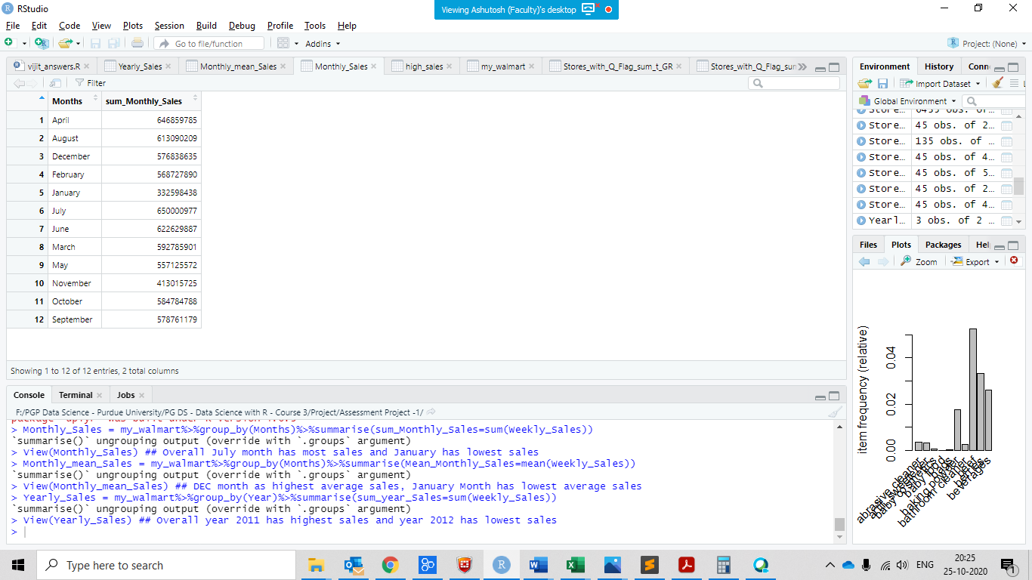 (ii) 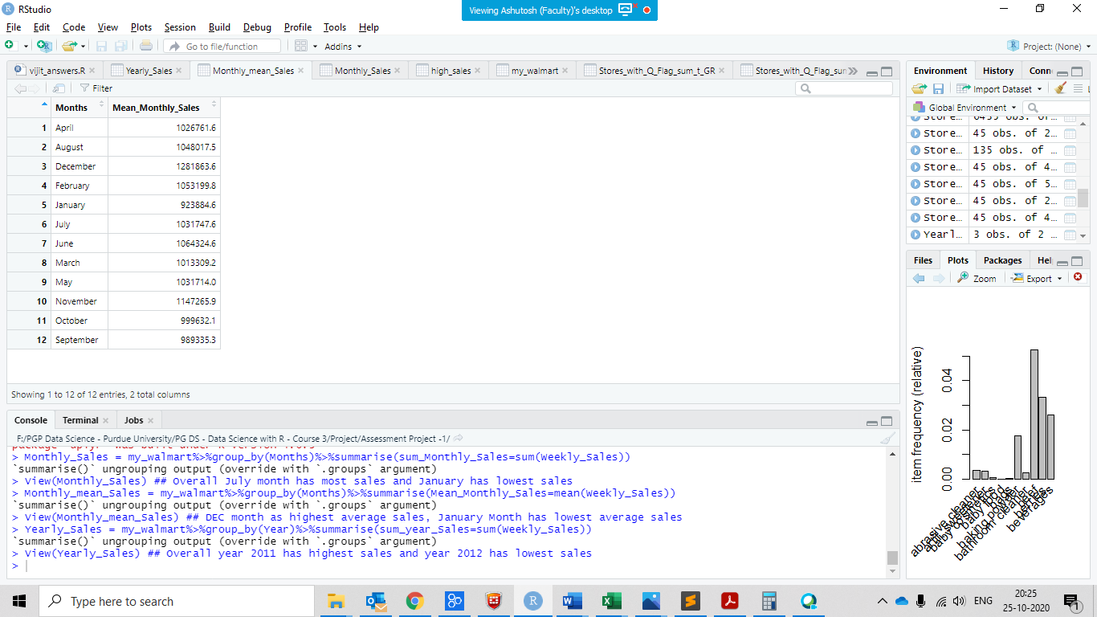 (iii) 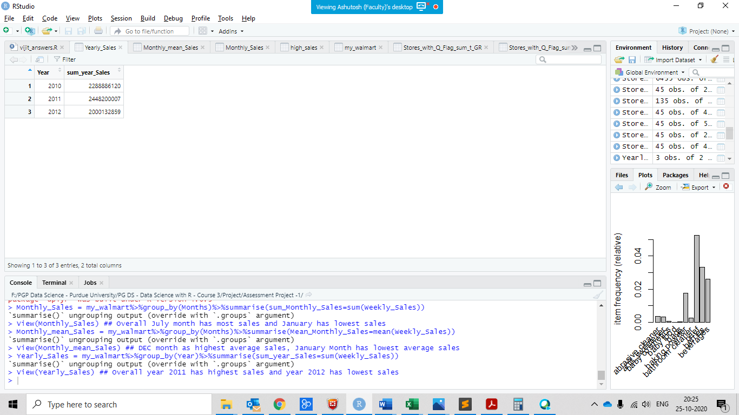

Insights:

1 - Overall July month has the most sales and January Month has the lowest sales

2- DEC month as highest average sales, January Month has lowest average sales

3- Overall year 2011 has highest sales and year 2012 has lowest sales

**----------------------------------------------------------------------------------------------------------------------------------------------------------------**

**Q 6 - Statistical Model**

**For Store 1 – Build prediction models to forecast demand**

* **Linear Regression – Utilize variables like date and restructure dates as 1 for 5 Feb 2010 (starting from the earliest date in order). Hypothesize if CPI, unemployment, and fuel price have any impact on sales.**
* **Change dates into days by creating new variable.**

**Select the model which gives best accuracy.**

**Ans 6 –**

Code:

library(lubridate)

my_walmart = read.csv('Walmart_Store_sales.csv')

View(my_walmart)

Str(my_walmart)

# Extracting Store 1 data from my_walmart

Store_one_data = my_walmart %>% filter(Store == 1)

View(Store_one_data)

days = c(1:143) ## creating vector for dates

Store_one_data = cbind(Store_one_data,day_id = days) ## restructure dates as 1 for 5 Feb 2010

View(Store_one_data)

str(Store_one_data)

summary(Store_one_data)

**## Linear model**

LM_Store_one = lm(Weekly_Sales~Fuel_Price+CPI+Unemployment ,Store_one_data)

summary(LM_Store_one)

# Fuel price is insignificant variable here and can be dropped

LM_Store_one = lm(Weekly_Sales~ CPI+Unemployment ,Store_one_data)

summary(LM_Store_one)

# Unemployment is also insignificant variable here and can be dropped

LM_Store_one = lm(Weekly_Sales~ CPI,Store_one_data)

summary(LM_Store_one)

## intercept : -190192 , R square : 0.05, Adjusted R square : 0.044, p value : 0.006 < 0.05

#Consumer Price Index has impact on Weekly Sales

Screenshots:

(i)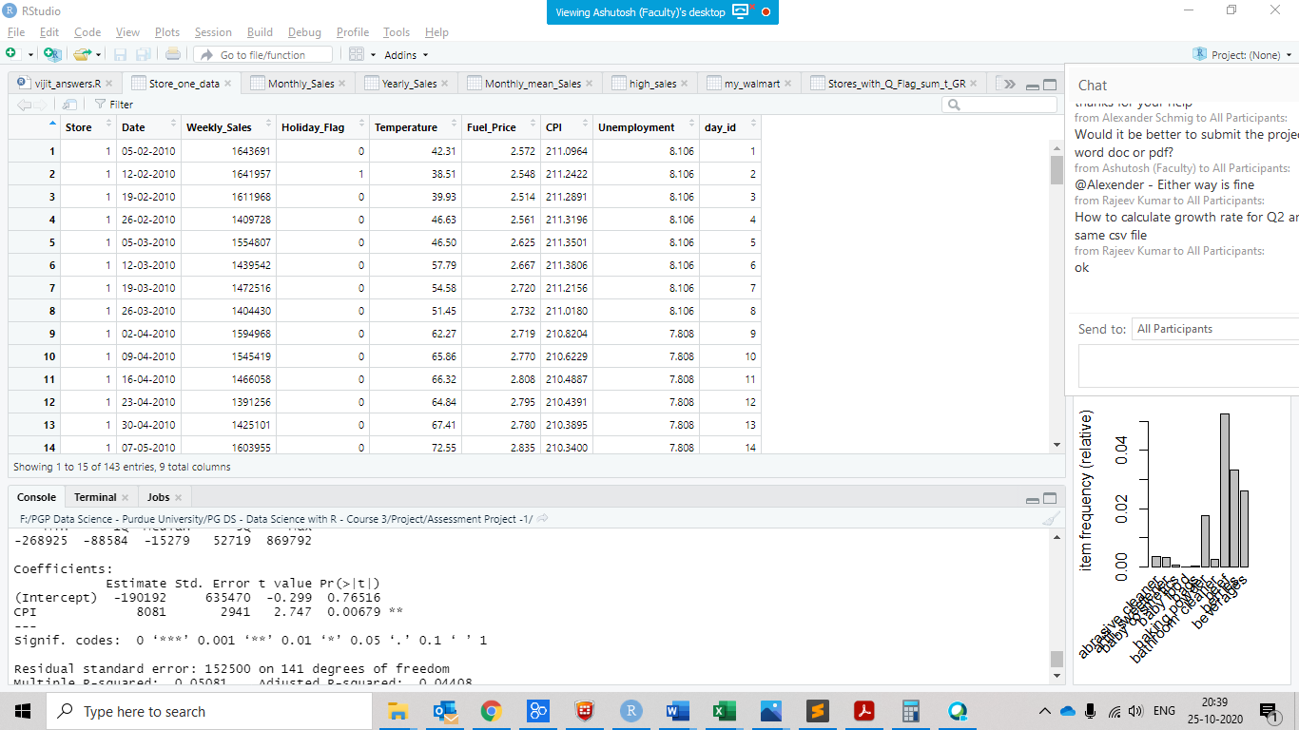

(ii) 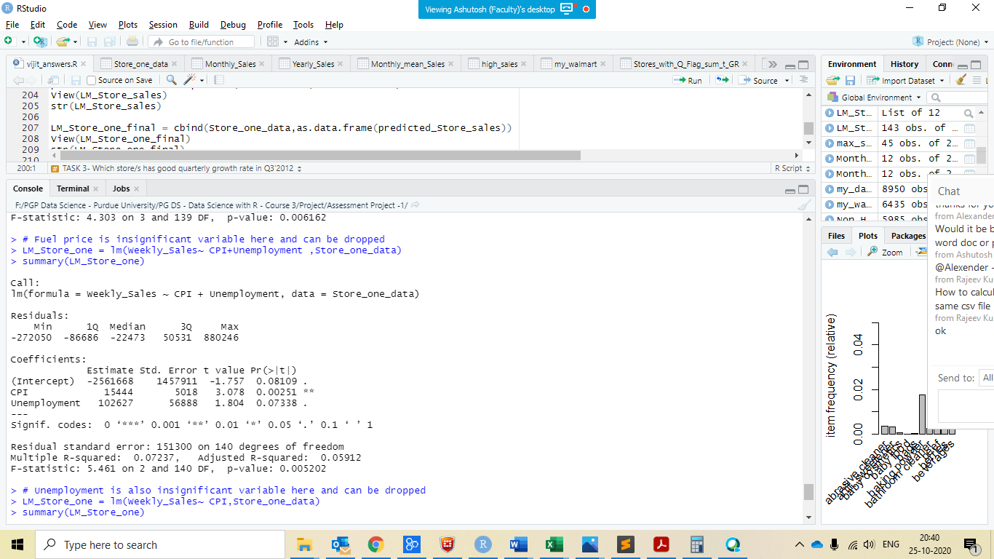(iii) 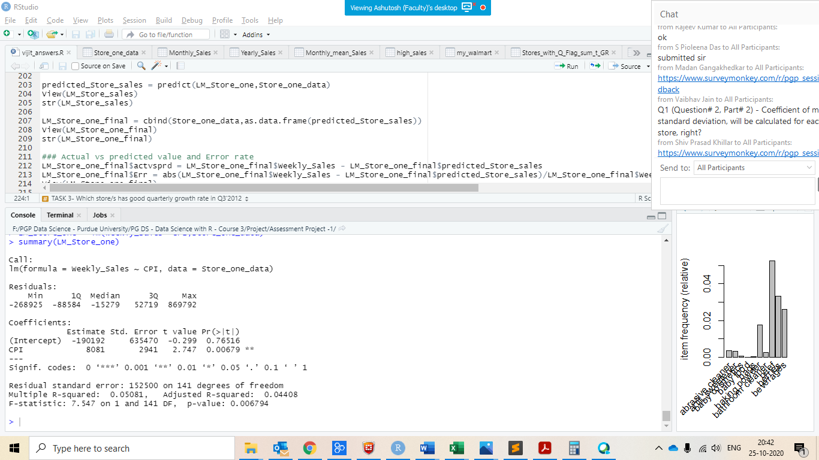

Insights:

1 - Fuel price and Unemployment are insignificant variables here

2 – p value of CPI is < 0.05 , Consumer Price Index has impact on Weekly Sales

3 – better the CPI the weekly sales is high

4 - intercept : -190192 , R square : 0.05, Adjusted R square : 0.044, p value : 0.006 < 0.05